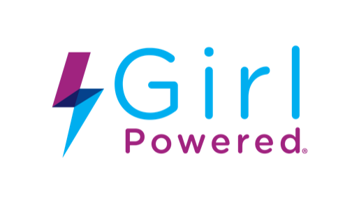
[Month Day, Year]
[Name of Person Letter is Addressed To]
[Company Name]
[Address]
[City, State Zip]
Dear [Mr. or Ms. Last Name]:
Our school, [full name of the school or group/club], is reaching out to invite you to support our Girl Powered Workshop event.
What Is It?
Girl Powered Workshops are in-person or virtual events with the goal to engage and inform young women about robotics education and competition opportunities they might not be aware of. We have been invited by the Robotics Education & Competition Foundation (RECF) to host our own Girl Powered Workshop during the month of October in honor of International Day of the Girl (October 11, [year]).
We are very excited to host this event and hope many girls in our community can experience the cool robots we will be building, as well as the fun games and activities throughout the day. Robotics Education is a great way to promote hands-on learning in the Science, Technology, Engineering, and Math (STEM) fields with the potential to nurture the new generation of engineers, pilots, rocket scientists and many more!
When Will It Take Place?
[Month Day, Year] from [start time] to [end time], at [location name].
What Is Needed?
We need and would love our community support! We are reaching out to our local community members and businesses such as yours to request support for this inspirational event. We would like to kindly ask for your business, [company name], support via a donation of [insert request here] for the event. Your generous support would be greatly appreciated and recognized.
Please let us know your interest in donating toward our big day, or any questions you may have. We can be reached at [insert phone number] or via email at [insert email].
Thank you for your consideration and partnership!
With warm regards,
[Signature here of school or club representative]

